**Spring Core_Maven**

**1.Configuring a Basic Spring Application**

**Pom.xml**

<project xmlns="http://maven.apache.org/POM/4.0.0"

xmlns:xsi="http://www.w3.org/2001/XMLSchema-instance"

xsi:schemaLocation="http://maven.apache.org/POM/4.0.0

http://maven.apache.org/xsd/maven-4.0.0.xsd">

<modelVersion>4.0.0</modelVersion>

<groupId>com.library</groupId>

<artifactId>LibraryManagement</artifactId>

<version>1.0.0</version>

<properties>

<maven.compiler.source>11</maven.compiler.source>

<maven.compiler.target>11</maven.compiler.target>

</properties>

<dependencies>

<dependency>

<groupId>org.springframework</groupId>

<artifactId>spring-context</artifactId>

<version>5.3.21</version>

</dependency>

</dependencies>

</project>

**applicationContext.xml**

<?xml version="1.0" encoding="UTF-8"?>

<beans xmlns="http://www.springframework.org/schema/beans"

xmlns:xsi="http://www.w3.org/2001/XMLSchema-instance"

xsi:schemaLocation="http://www.springframework.org/schema/beans

http://www.springframework.org/schema/beans/spring-beans.xsd">

<bean id="bookRepository" class="com.library.repository.BookRepository"/>

<bean id="bookService" class="com.library.service.BookService">

<property name="bookRepository" ref="bookRepository"/>

</bean>

</beans>

**BookRepository.java**

package com.library.repository;

import java.util.*;

public class BookRepository {

private List<String> books = new ArrayList<>(Arrays.*asList*("Java", "Spring"));

public void addBook(String book) { books.add(book); }

public void removeBook(String book) { books.remove(book); }

public void displayBooks() { System.*out*.println("Books: " + books); }

}

**BookService.java**

package com.library.service;

import com.library.repository.BookRepository;

public class BookService {

private BookRepository bookRepository;

public void setBookRepository(BookRepository bookRepository) { this.bookRepository = bookRepository; }

public void addBook(String book) { bookRepository.addBook(book); }

public void removeBook(String book) { bookRepository.removeBook(book); }

public void showAllBooks() { bookRepository.displayBooks(); }

}

**LibraryManagementApp.java**

package com.library.main;

import org.springframework.context.ApplicationContext;

import org.springframework.context.support.ClassPathXmlApplicationContext;

import com.library.service.BookService;

public class LibraryManagementApp {

public static void main(String[] args) {

ApplicationContext context = new ClassPathXmlApplicationContext("applicationContext.xml");

BookService service = (BookService) context.getBean("bookService");

service.showAllBooks();

service.addBook("Hibernate");

service.showAllBooks();

service.removeBook("Java");

service.showAllBooks();

}

}

**Output:**

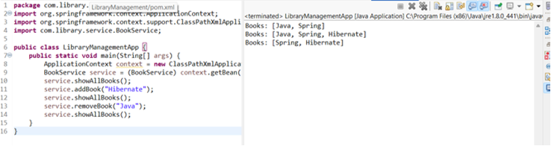

**2.Implementing Dependency Injection**

**applicationContext.xml**

<?xml version="1.0" encoding="UTF-8"?>

<beans xmlns="http://www.springframework.org/schema/beans"

xmlns:xsi="http://www.w3.org/2001/XMLSchema-instance"

xsi:schemaLocation="http://www.springframework.org/schema/beans

http://www.springframework.org/schema/beans/spring-beans.xsd">

<bean id="bookRepository" class="com.library.repository.BookRepository"/>

<bean id="bookService" class="com.library.service.BookService">

<property name="bookRepository" ref="bookRepository"/>

</bean>

</beans>

**BookRepository.java**

package com.library.repository;

import java.util.*;

public class BookRepository {

private List<String> books = new ArrayList<>(Arrays.*asList*("Java", "Spring"));

public void addBook(String book) { books.add(book); System.*out*.println("Added: " + book); }

public void removeBook(String book) { books.remove(book); System.*out*.println("Removed: " + book); }

public void displayBooks() { System.*out*.println("Books: " + books); }

}

**BookService.java**

package com.library.service;

import com.library.repository.BookRepository;

public class BookService {

private BookRepository bookRepository;

public void setBookRepository(BookRepository bookRepository) {

this.bookRepository = bookRepository;

System.*out*.println("BookRepository injected!");

}

public void performOperations() {

bookRepository.displayBooks();

bookRepository.addBook("Hibernate");

bookRepository.displayBooks();

}

}

**LibraryManagementApp.java**

package com.library.main;

import org.springframework.context.ApplicationContext;

import org.springframework.context.support.ClassPathXmlApplicationContext;

import com.library.service.BookService;

public class LibraryManagementApp {

public static void main(String[] args) {

ApplicationContext context = new ClassPathXmlApplicationContext("applicationContext.xml");

BookService service = (BookService) context.getBean("bookService");

service.performOperations();

}

}

**Output:**

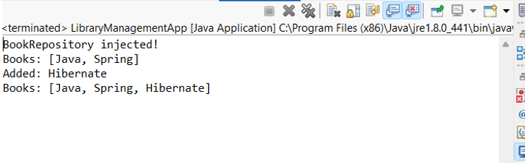

**4.Creating and Configuring a Maven Project**

**Pom.xml**

<?xml version="1.0" encoding="UTF-8"?>

<project xmlns="http://maven.apache.org/POM/4.0.0"

xmlns:xsi="http://www.w3.org/2001/XMLSchema-instance"

xsi:schemaLocation="http://maven.apache.org/POM/4.0.0

http://maven.apache.org/xsd/maven-4.0.0.xsd">

<modelVersion>4.0.0</modelVersion>

<groupId>com.library</groupId>

<artifactId>LibraryManagements</artifactId>

<version>1.0.0</version>

<packaging>jar</packaging>

<name>LibraryManagements</name>

<properties>

<maven.compiler.source>1.8</maven.compiler.source>

<maven.compiler.target>1.8</maven.compiler.target>

<spring.version>5.3.21</spring.version>

</properties>

<dependencies>

<!-- Spring Context -->

<dependency>

<groupId>org.springframework</groupId>

<artifactId>spring-context</artifactId>

<version>${spring.version}</version>

</dependency>

<!-- Spring AOP -->

<dependency>

<groupId>org.springframework</groupId>

<artifactId>spring-aop</artifactId>

<version>${spring.version}</version>

</dependency>

<!-- Spring WebMVC -->

<dependency>

<groupId>org.springframework</groupId>

<artifactId>spring-webmvc</artifactId>

<version>${spring.version}</version>

</dependency>

</dependencies>

<build>

<plugins>

<!-- Maven Compiler Plugin -->

<plugin>

<groupId>org.apache.maven.plugins</groupId>

<artifactId>maven-compiler-plugin</artifactId>

<version>3.8.1</version>

<configuration>

<source>1.8</source>

<target>1.8</target>

</configuration>

</plugin>

</plugins>

</build>

</project>

**MavenSetupTest.java**

package com.library.test;

import org.springframework.context.ApplicationContext;

import org.springframework.context.support.ClassPathXmlApplicationContext;

public class MavenSetupTest{

public static void main(String[] args){

System.*out*.println("Maven project setup successful!");

System.*out*.println("Spring Context: " + ApplicationContext.class.getName());

System.*out*.println("Java Version: " + System.*getProperty*("java.version"));

}

}

**Output:**

